**3. RCBM Strategy**

The methodology for the application of RCBM strategy consists of formulation of a better and efficient ‘Maintenance Policy’ based on Reliability analysis of components from maintenance records and evaluation of a ‘Cost Model’ (described in subsequent sub-sections), in order to achieve economical and effective maintenance. This is followed by optimization of maintenance schedules for each component, in order to minimize the overall cost of maintenance.

The aforementioned methodology incorporates following assumptions:

1. If a component is replaced during regular maintenance or unexpected failures, the reliability of the component will be restored to 100% after replacement.
2. The time window for optimized cost calculation and applied maintenance strategy is based on the existing maintenance period (3060 days) for fair comparison.
3. The failure mechanism of one component does not interact or influence the same for another to maintain simplicity.

***3.1 Reliability Based ‘Maintenance Policy’***

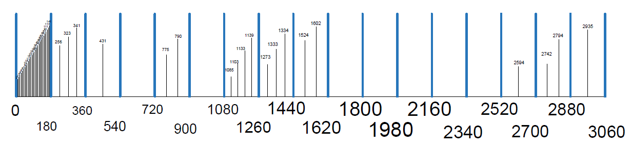In order to design a new maintenance policy, the maintenance records from the hospital, for a duration of about 8 years is studied. The current maintenance policy revolves around cyclic maintenance of 180 days wherein faults are diagnosed during regular maintenance or unexpected failures, and rectified by replacing the faulty component. Figure 3 shows the stick-diagram for the existing maintenance strategy of a component presented as a Network Terminal Box (NTB) for illustration. The blue dotted sticks represent 180-day regular maintenance and the black-small sticks represent the actual failures that happened in-between regular maintenance cycles.

*Figure 3. Stick-diagram for the existing maintenance strategy of a component presented as Network Terminal Box, for illustration.*

Figure 3 highlights two major issues associated with the existing maintenance strategy. *Firstly*, the initial failures (within the first 180 days) are large in number which was not detected earlier before our analysis, and *secondly*, unexpected failures occur quite often, in-between regular maintenance period. All these lower the operational availability of the equipment, and increases the incurred cost due to unexpected maintenance and the need of spare machines in order to maintain high availability. The first issue can be detected through standard data logging. However, the second issue requires the study of the reliability of each component.

In order to improve the existing maintenance strategy, the maintenance record for each of the 19 components mentioned in Table I, comprising the Haemodialysis machine is analysed using Weibull++ v10 by Reliasoft. The failure times and reliability of each component (excluding initial failures) are estimated using the Cumulative Distribution Function (CDF) based on specific statistical distribution associated with the specific components as shown in Table II. Assuming the reliability of each component must be above 0.97, which implies that the chance of the failure of each component is only 0.03, we can derive a suitable maintenance cycle for each component as shown in Table III.

*Table II. 220-Day Maintenance Scheduling based on Reliability Data. (without considering the initial failures)*

|  |  |  |  |
| --- | --- | --- | --- |
| **S. No** | **Component** | **Associated Statistical Distribution** | **Distribution Parameters** |
| 1 | M29 | 2P-Weibull | Beta: 2.49, Eta (Day): 971.02 |
| 2 | V39 | 3P-Weibull | Beta: 1.32, Eta (Day): 5345.53, Gamma (Day): 89.06 |
| 3 | RV | 2P-Weibull | Beta: 2.30, Eta (Day): 2612.57 |
| 4 | TMP | 2P-Weibull | Beta: 2.10, Eta (Day): 3736.00 |
| 5 | NTB | 2P-Weibull | Beta: 2.08, Eta (Day): 2743.23 |
| 6 | BLD | 3P-Weibull | Beta: 0.74, Eta (Day): 4050.97, Gamma (Day): 196.61 |
| 7 | G29 | Lognormal | Log-Mean (Day): 7.34, Log-Std: 0.70 |
| 8 | F210 | Gamma | Mu (Day): 7.77, K: 1.78 |
| 9 | M21 | 3P-Weibull | Beta: 1.93, Eta (Day): 1833.00, Gamma (Day): 4.19 |
| 10 | RCh | 2P-Weibull | Beta: 1.55, Eta (Day): 9503.80 |
| 11 | CCB | 3P-Weibull | Beta: 0.89, Eta (Day): 21327.93, Gamma (Day): 351.63 |
| 12 | ST | Lognormal | Log-Mean (Day): 7.99, Log-Std: 0.15 |
| 13 | AKOR | Lognormal | Log-Mean (Day): 8.46, Log-Std: 0.76 |
| 14 | 65R | 3P-Weibull | Beta: 2.24, Eta (Day): 3711.45, Gamma (Day): 375.00 |
| 15 | FC | Gamma | Mu (Day): 8.24, Gamma (Day): 1.82 |
| 16 | PS | 2P-Weibull | Beta: 2.08, Eta (Day): 3579.83 |
| 17 | CP | 2P-Weibull | Beta: 1.47, Eta (Day): 12556.33 |
| 18 | HP | Lognormal | Log-Mean (Day): 8.70, Log-Std: 0.70 |
| 19 | AKT | Lognormal | Log-Mean (Day): 7.96, Log-Std: 0.37 |

*Table III. 220-Day Maintenance Scheduling based on Reliability Data.*

|  |  |  |  |  |
| --- | --- | --- | --- | --- |
| Maintenance Cycle | Components of-concern to be maintained in | | | Total No. of Components to be maintained |
| ***220 days*** | ***440 days*** | ***1100 days*** |
| *1st cycle on 220th day* | M29, V39, RV, TMP, NTB, BLD, G29, F210, M21, RCh | - | - | 10 |
| *2nd cycle on 440th day* | M29, V39, RV, TMP, NTB, BLD, G29, F210, M21, RCh | CCB, ST, AKOR, 65R, FC, PS, CP | - | 17 |
| *3rd cycle on 660th day* | M29, V39, RV, TMP, NTB, BLD, G29, F210, M21, RCh | - | - | 10 |
| *4th cycle on 880th day* | M29, V39, RV, TMP, NTB, BLD, G29, F210, M21, RCh | CCB, ST, AKOR, 65R, FC, PS, CP | - | 17 |
| *5th cycle on 1100th day* | M29, V39, RV, TMP, NTB, BLD, G29, F210, M21, RCh | - | HP, AKT | 12 |
| *6th cycle on 1320th day* | M29, V39, RV, TMP, NTB, BLD, G29, F210, M21, RCh | CCB, ST, AKOR, 65R, FC, PS, CP | - | 17 |
| *7th cycle on 1540th day* | M29, V39, RV, TMP, NTB, BLD, G29, F210, M21, RCh | - | - | 10 |
| *8th cycle on 1760th day* | M29, V39, RV, TMP, NTB, BLD, G29, F210, M21, RCh | CCB, ST, AKOR, 65R, FC, PS, CP | - | 17 |
| *9th cycle on 1980th day* | M29, V39, RV, TMP, NTB, BLD, G29, F210, M21, RCh | - | - | 10 |
| *10th cycle on 2200th day* | M29, V39, RV, TMP, NTB, BLD, G29, F210, M21, RCh | CCB, ST, AKOR, 65R, FC, PS, CP | HP, AKT | 19 |
| *11th cycle on 2420th day* | M29, V39, RV, TMP, NTB, BLD, G29, F210, M21, RCh | - | - | 10 |
| *12th cycle on 2640th day* | M29, V39, RV, TMP, NTB, BLD, G29, F210, M21, RCh | CCB, ST, AKOR, 65R, FC, PS, CP | - | 17 |
| *13th cycle on 2860th day* | M29, V39, RV, TMP, NTB, BLD, G29, F210, M21, RCh | - | - | 10 |
| *14th cycle on 3080th day* | M21, RCh | - | - | 2 |

From our reliability analysis of the components, we found that their reliabilities are adequately high, apart from their early failure, and thus 180-days maintenance cycle is too conservative. Also, Table III shows that not all the 19 components need to be maintained during the regular maintenance. In a given period of 3060 days, 10 components including M29, V39, RV, TMP, NTB, BLD, G29, F210, M21, RCh are to be maintained every 220 days, 7 components including CCB, ST, AKOR, 65R, FC, PS, CP are to be maintained every 440 days, 2 components including HP, AKT are to be maintained every 1100 days. The 14th cycle has an exception of only 2 components (M21 and RCh) instead of 10 in 220 day cycle. Figure 4 shows the suggested 220-day maintenance strategy.

On comparing the current 180-days maintenance policy with the suggested 220-days maintenance policy, one can obtain the following major advantages:

* + Number of maintenance cycles reduce to 14 cycles from 17 in a given period of 3060 days.
  + The regular maintenance cost reduces by 18.18%.
  + This results in a total saving of 18,279 New Taiwan Dollar (NTD) per year per machine (excluding initial and unexpected failures’ consideration)

The initial failures are not included in the cost saving calculations because those can be avoided by considering better quality components or by considering a different vendor. In order to study the cost saving including the unexpected failures, a Cost-Model is presented in the next sub-section

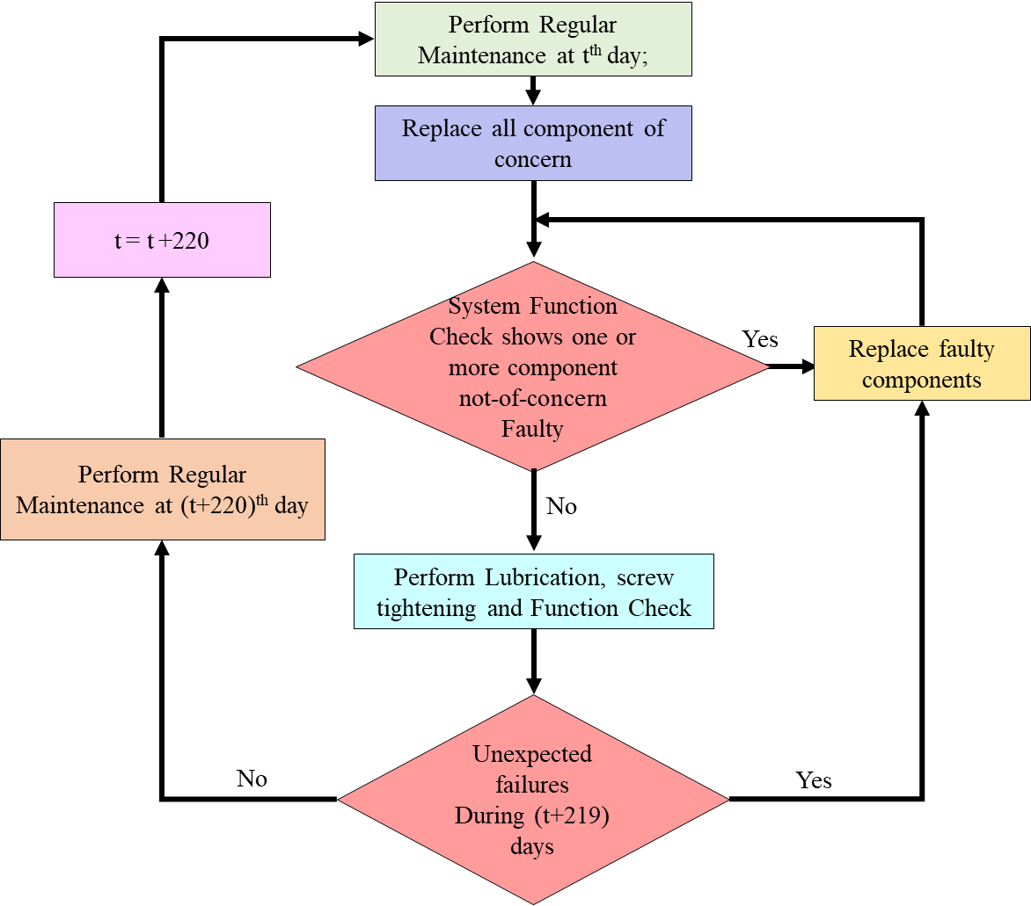

*Figure 4. Suggested 220-day maintenance policy*